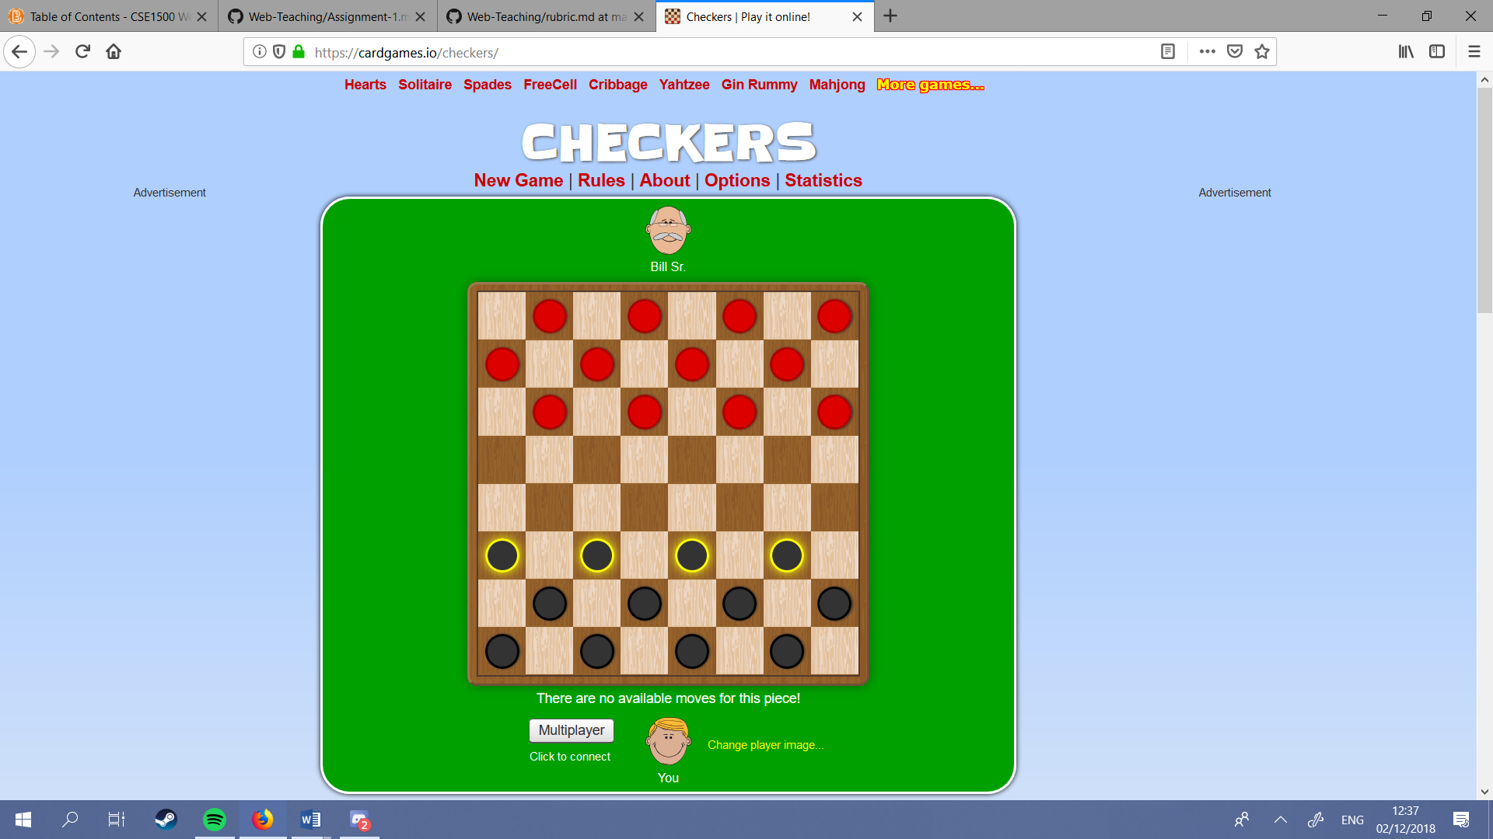<https://cardgames.io/checkers/>

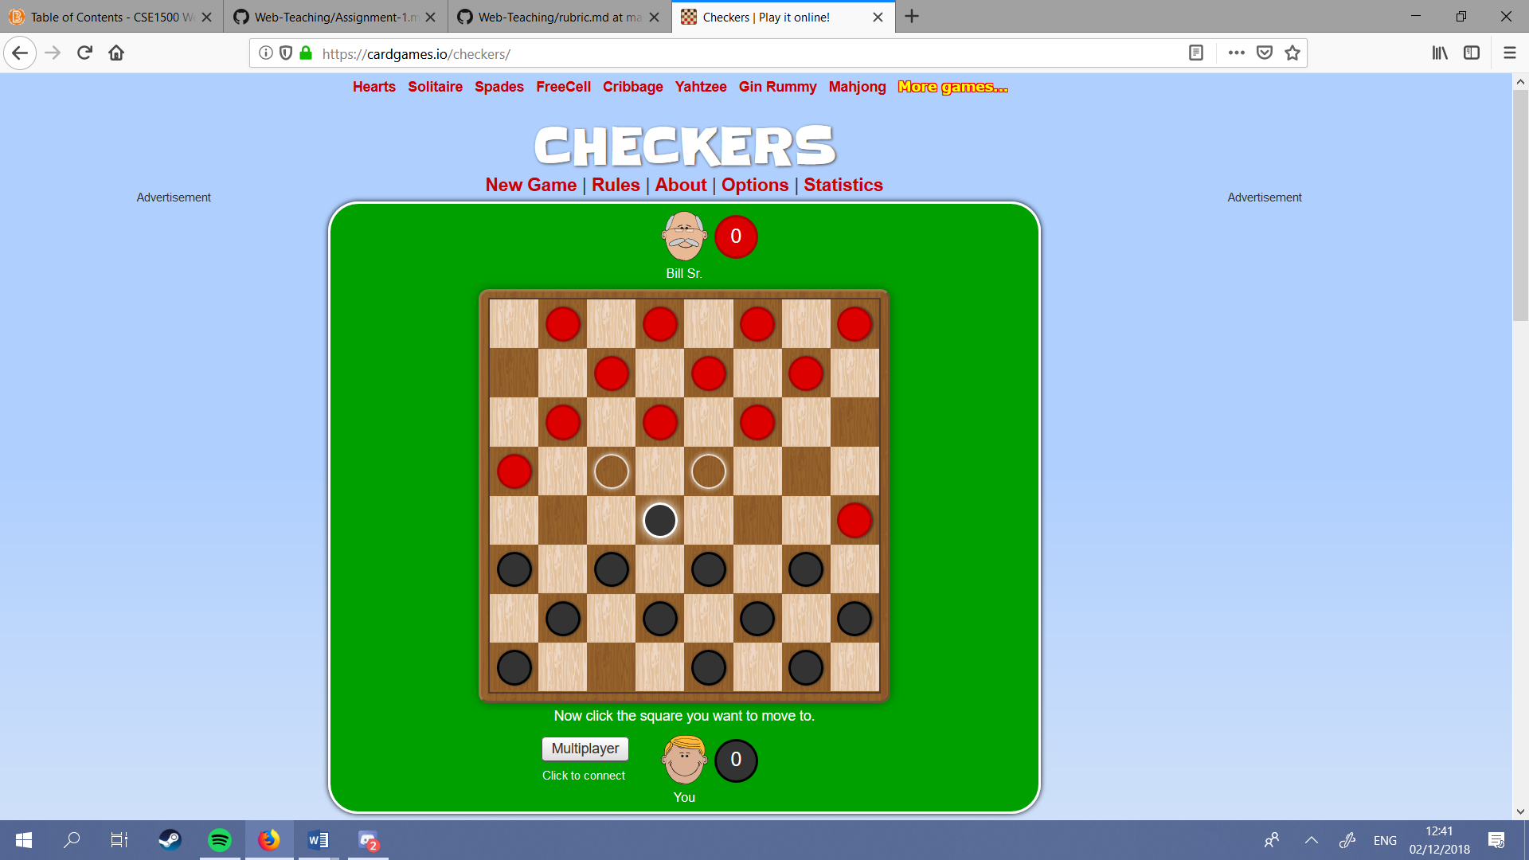

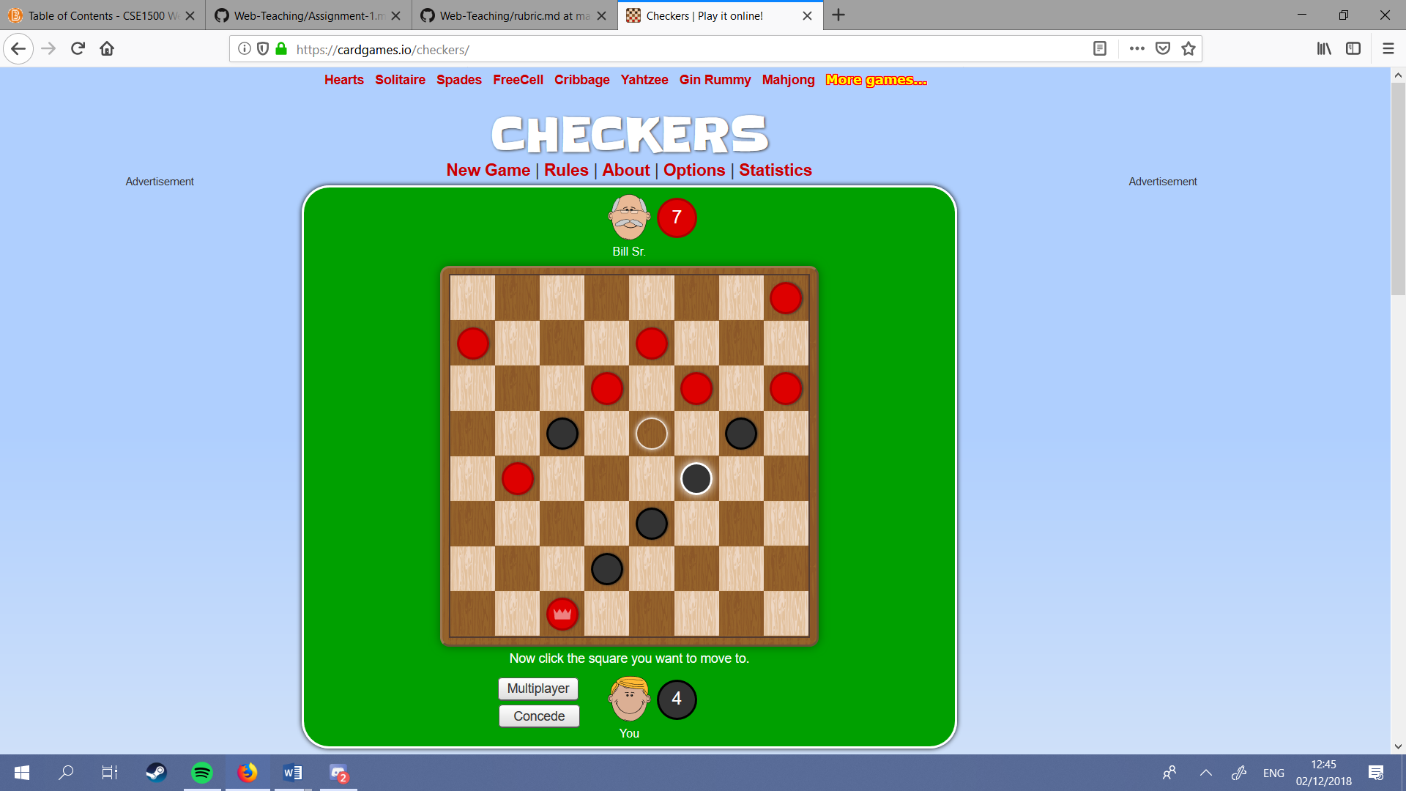

# Like:

1. Kill counters
2. Legal moves highlighted
3. Pieces that are able to move are highlighted
4. Concede button and possibility to choose between multiplayer and single player
5. Animations

# Dislike:

1. When selecting a piece you have to click on a piece unable to move to deselect it (instead of just a random square)
2. The text at the bottom doesn’t add anything: it’s just clutter
3. The buttons lack stylesheets

# 

# Likes elaborated

This example seems a very functional checkers game. Nothing is too beautiful and some things are just plain ugly. However it is a working game with all functionalities that you’d expect. There are ‘kill counters’ to show how many pieces you and your opponent have captured, the pieces that are able to move have been highlighted and , when selected, the places they are able to move to have also been highlighted. Furthermore there are buttons that allow you to concede to your opponent or decide to change your game into a multiplayer game.

# Dislikes elaborated

The game however does have some crude unfinished or not that well thought out parts. When selecting a piece it is hard to deselect it (you have to click on a piece that is unable to move) and it’s hard to find the pieces that are able to move. This is because they lose their highlight when a different piece is selected. Then there is some weird explanatory text at the button that is mostly just clutter, and isn’t really worth paying attention to. In my own game this will probably not be implemented. The last problem with this game is the lack of stylesheets for the buttons, and the general unpolished look of the game. While I can’t say my game would look better I’d like it to

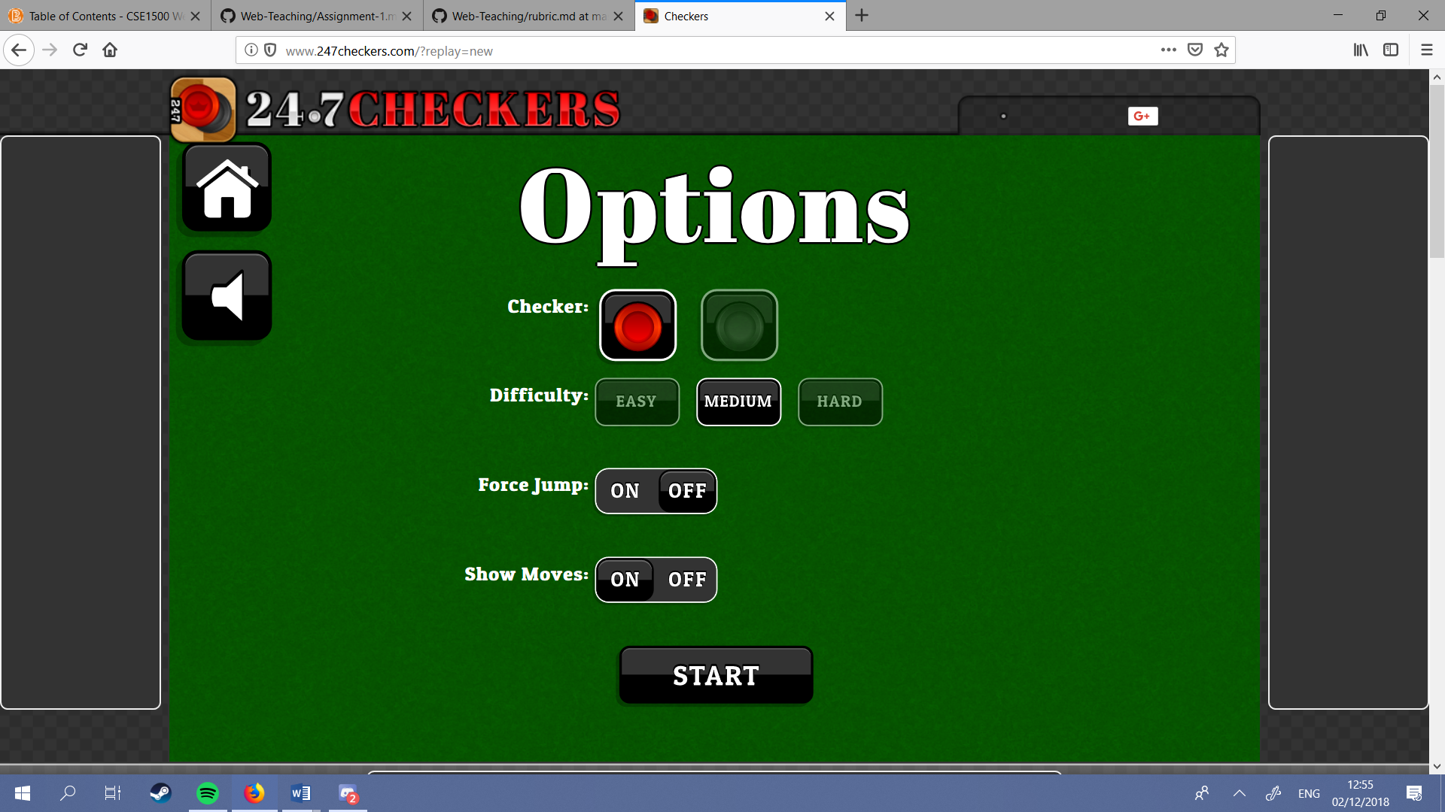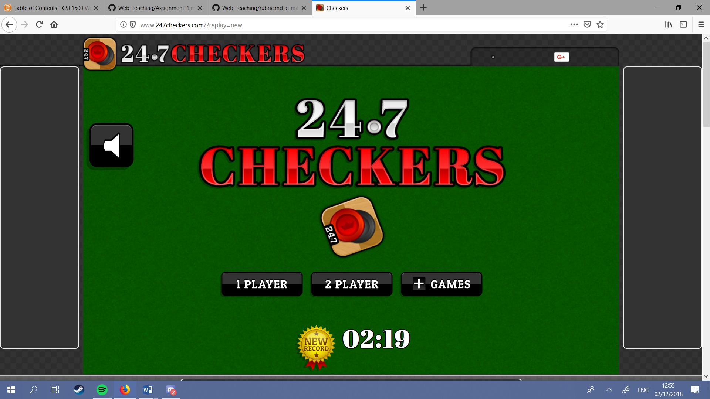

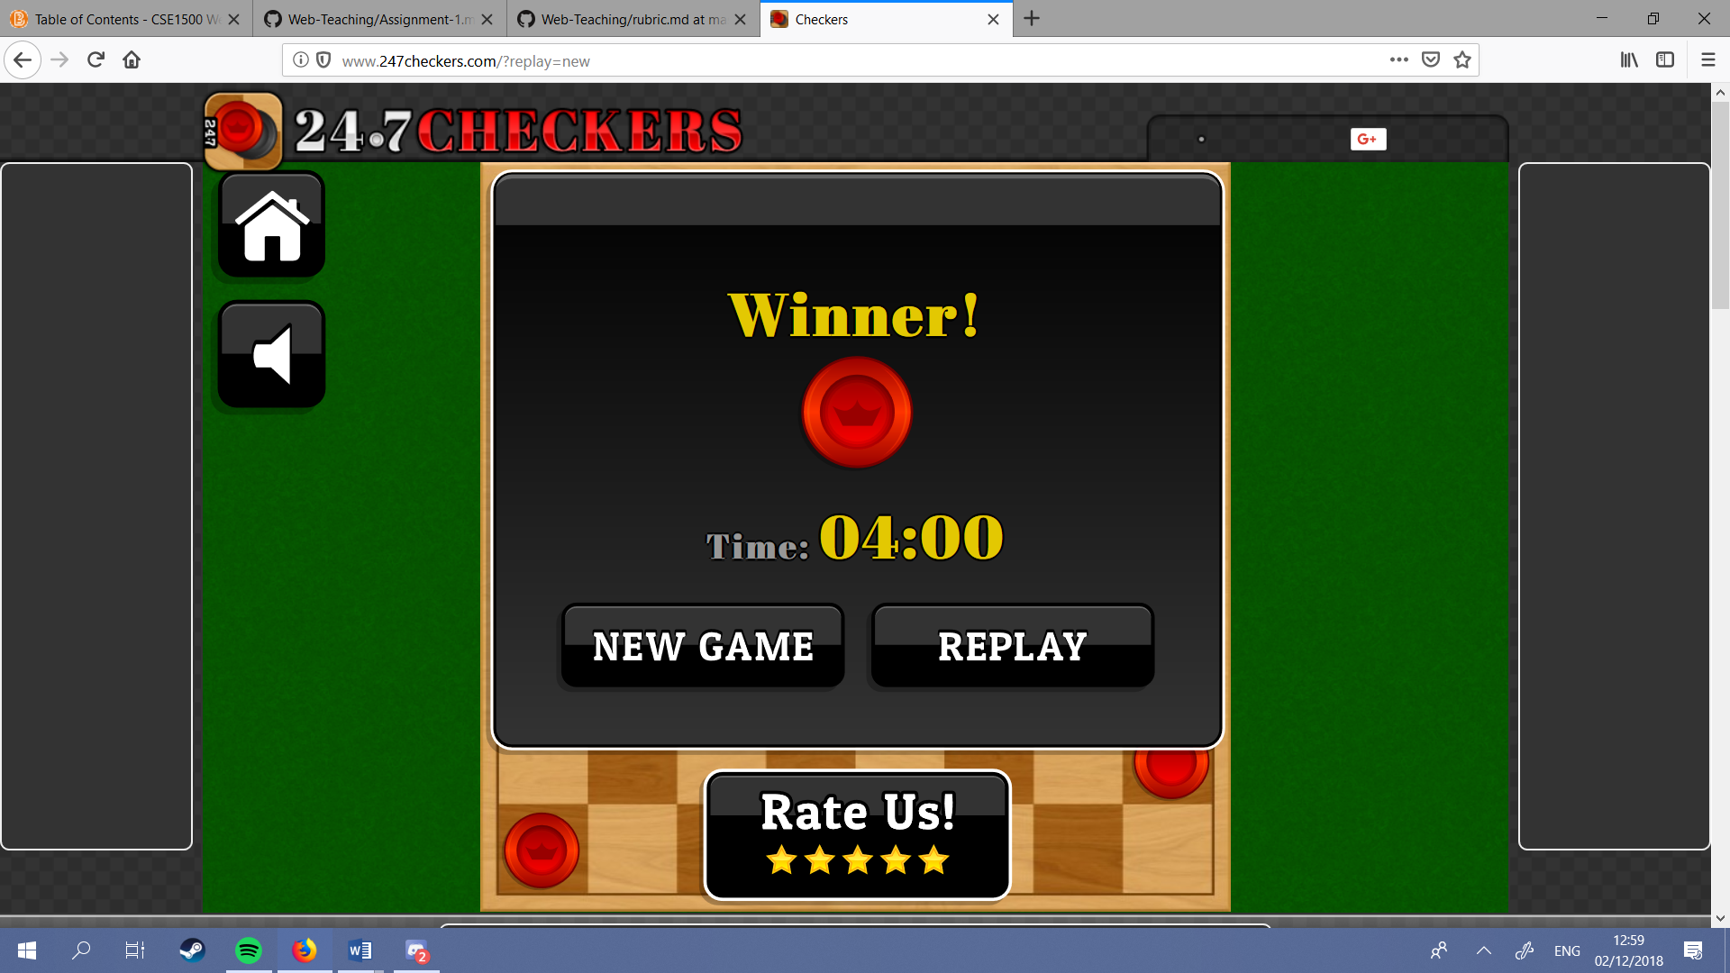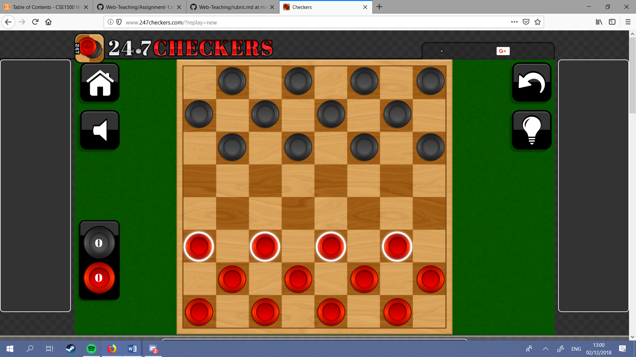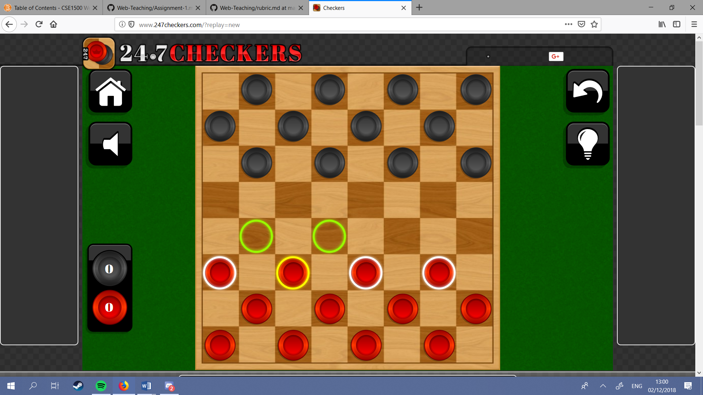

# Likes:

1. Very nice buttons and menu’s
2. Customisable games (difficulty and UI)
3. Highlighted legal pieces
4. Highlighting legal moves of a piece keeps other legal pieces highlighted
5. ‘kill counter’
6. Timer
7. Hints and undo buttons
8. Home and sound button
9. Very nice sprites

# Dislikes

1. The amount of UI buttons (and their size) makes the game look cluttered
2. The name
3. The main menu feels empty

# Likes elaborated

This game actually looks as amazing as I could possibly expect from a checkers game. It has 4 functional menu’s with very well stylized buttons and functional sprites. As well as an implemented timer to show how long it took for you to beat your opponent. The game has various extra functionalities like an undo button a hints button, a sound button and a back to home screen menu. Furthermore the highlights are better thought out in comparison to the previous game: when a piece is selected, the other pieces remain highlighted. The selected unit gets a yellow highlight colour and it’s legal moves are shown.

# Dislikes elaborated

As good as this game is executed there are still some things I would like to see differently; the amount of buttons on the game screen make it feel a little bit cluttered and hard to oversee. This has the result that these buttons are mostly just ignored. The name of the game makes it seem like a cheap knockoff version and the main menu seems empty and boring. This could be changed by picking a different background